

We serve creative cuisine. And worthy causes.

Present this certificate to your server and your cause will receive
15% of your total purchase* every Tuesday during April.

Name of Organization:

BOSTON AREA GLEANERS

Valid:

April 7th, 14th, 21st and 28th.
*Excludes Alcohol, Tax and Gratuity

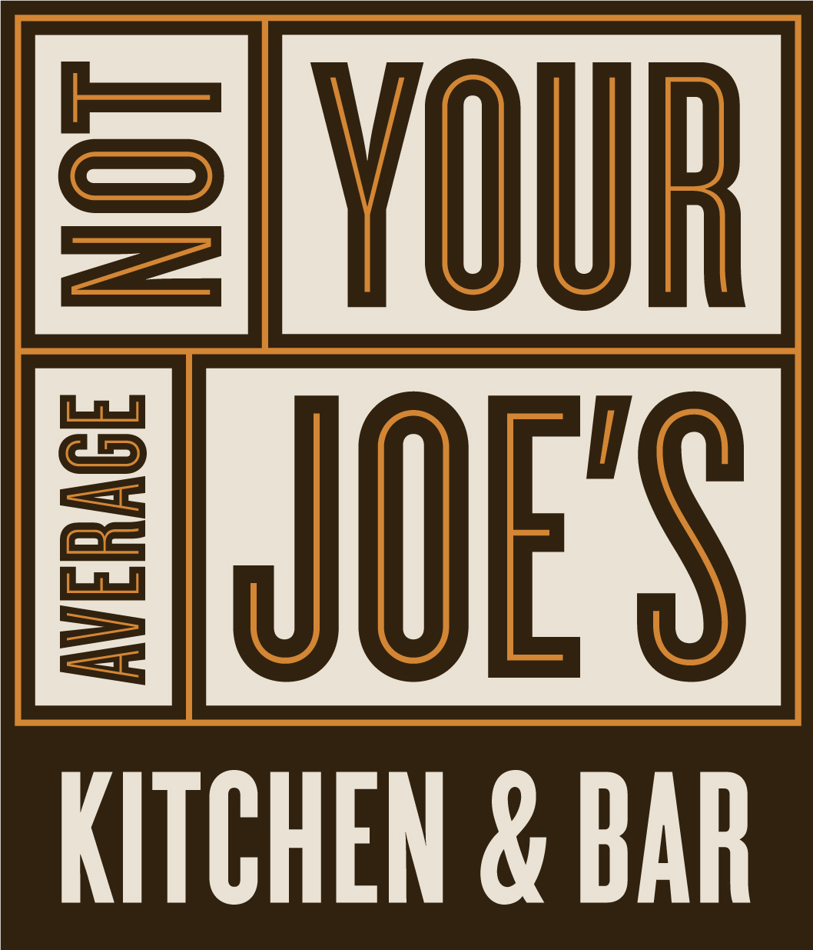

55 Main Street • Watertown • 617-926-9229

